

**The University of Manila**

546 Mariano V delos Santos St. Sampaloc Manila

The Developing of

Grading System

for Distributed Grading

in SHS students of ABIS.

A Thesis Presented

to the faculty of the

College of Computer Science

In Partial Fulfillment of the Requirements

of the Subject System Analyst and Design 2

of Bachelor of Science in Computer Science

Presented by:

Toni Grace A. Balatbat

John Paul E. Gutierrez

Crystyn Moira G. Oledan

Mia Abegail F. Palmario

Ma. Cristina Pugoy

Rafael S. Ricablanca

Elaine Marie Simpas

Table of Contents

ACKNOWLEDGEMENT 3

INTRODUCTION 4-5

HISTORY 6-7

MISSION 8

VISION 8

BACKGROUND OF THE STUDY 9

ORGANIZATIONAL CHART 10-11

STATEMENT OF THE PROBLEM 12

OBJECTIVE OF THE STUDY 13

REVIEW OF RELATED LITERATURE 14

ForeignLiterature 14-15

LocalLiterature 15-16

OLD SYSTEM 17-18

OLD SYSTEM FLOWCHART 19

NEW SYSTEM 20

DATA FLOW DIAGRAM 21

SYSTEM FLOWCHART 22-27

PROGRAM FLOWCHART 28-33

DEFINITION OF TERMS 34-35

HARDWARE AND SOFTWARE REQUIREMENTS 35

Hardware 35

Software 35

CONCLUSION 36

SUMMARY 37

RECOMMENDATION 38

BIBLIOGRAPHY 39

# ACKNOWLEDGEMENT

First and foremost, we would like to thank our professor, Mr. Rogelio Plaza Jr., for making this thesis possible. We also want to express our gratitude to our family, without their help and guidance, we wouldn’t be able to finish this project, and lastly, to my classmates for giving their best just to accomplish this project.

Thank you also to Google for the resources that helped us finish our thesis on time by providing examples, defining some terms, checking our grammar, and assisting us in paraphrasing our paragraph.

Above all, to the great Almighty, our Lord and Savior, for giving us the strength to get through this study, also for wisdom and knowledge to explore things, to surpass all these challenges and trials, we are thankful to our Lord.

**INTRODUCTION**

Computer world is now at our hands, this gives improvement and development of all programs in the different agencies, in offices and in schools. Paper work become easy, computation is faster, record keeping and bringing out is fast.

Grading is the process of summating student achievement using a numerical or ordinal scale, is a complex evaluative practice that requires teachers to make judgments about student learning. Grades are used, most notably, to make public statements to students, parents, principals, and other educators about student achievement.

Computation of grades in school became easy for modern teacher but for tradition alone they found difficult but now no burden in recording, transmitting, giving the equivalent and the final grades for teachers who are computer literate, where time, effort and energy is minimized.

Here in the Philippines, many are still manually computing the grades of students. The cons of this procedure were the usual human errors, and it is just like in ABIS, where they use manual processes to calculate and release the student’s grades.

The Andres Bonifacio Integrated School, is one of the big schools in the Division of Mandaluyong situated at the most populated barangay, Addition Hills. Many teachers to their faculties, they manually input those data on a grading sheet nor in MS Excel in computation of grades. Also, they are using report card on releasing the grades to the students. It will cause a lot of time to prepare this.

The researchers will propose to design and develop an Online Grading System that to help and give information to Andres Bonifacio Integrated School. Now, with the technology which is to be developed a system, it will enable them to do more with less effort. By creating these automatable systems, it is friendly for users and focuses on the accuracy of grades, consistency of the computation, and avoiding inconsistency of data. Computers enable the efficient processing and storage of information. Online or automated can help save time on administrative tasks and give teachers more time to do a lot, especially if it is very important.

# HISTORY

Forty-nine years have passed since the founding of Andres Bonifacio Integrated School (ABIS). From its humble beginnings in the street of M. Gonzaga, the school that was merely composed of four rented rooms evolved into a four storey building located in Welfareville Compound.

1962 marked the birth of ABIS as a unit of Eulogio Rodriguez Elementary School and was named as ERES 1. It initially catered the grade one pupils.

The following year, Mrs. Angelita Vera Cruz was designated as the school head teacher signaling the start of various changes for the institution. The four rooms transformed into a building to be able to accommodate a complete elementary education. Upon Mrs. Vera Cruz appointment as the principal of main school, Mrs. Matoto assigned the leadership.

Year 1978, a new school was established near ERES 1. Subsequently, twenty of the teachers were transferred to the newly established school known as Doña Pilar Gonzaga Elementary School. Mrs. Matoto was one of those who were transferred and thus, was replaced by Mrs. Ligaya Sacramento who took over the reign of ERES.

After two years, there was another change of leadership with Mrs. Erlinda Celestial appointment as the new head of the school. Under her reign, she pushed for the institution change of name.

Finally, in 1985, the school was officially named Andres Bonifacio Elementary School. Soon after Mrs. Susana Toribio took over the responsibility, ABES simultaneously transferred to a new site. The school was housed at the former KADIWA Center inside Welfareville Compound after which the constitution under-went several changes of leadership from Mrs. Emelinda Osilo, Ms. Josefina Anselmo, Ms. Ruth Bautista, Mrs. Gregoria Ignacio, Mrs. Evelyn Sto. Tomas up to Mrs. Wilhelmina Bautista.

In 1998, with the influx of enrollees, the leaders of the school realized the need for a bigger facility. Fortunately, through the help of the late Senator Neptali A. Gonzales Sr., the project to establish a new building was started in May of the same year.

On July 30, 2001 the law converting the institution from an elementary school into an integrated school was enacted by virtue of Republic Act No. 9144. The law was initiated by Congressman Neptali M. Gonzales II to answer the growing problem of congestion in the existing national high schools in Mandaluyong.

As such in 2002, under the able leadership of Dr. Juanita P. Valle, the school opened its doors to first year students, simultaneously to its transfer to a bigger and better home.

Truly, ABIS has gone a long way but through it all, the school has never faltered in its quest to provide quality education for the nation’s future leaders.

# MISSION

To provide access to quality basic education for the development of literacy, numeracy, thinking and work skills, proper attitudes and desirable values of individuals for them to become caring, self-reliant, productive, socially aware, patriotic and responsible citizens.

# VISION

ANDRES BONIFACIO INTEGRATED SCHOOL (ABIS) is an educational institution that envisions empowered individuals who demonstrate practical knowledge, life skills, attitudes and values to make them productive, nationalistic and God-loving members of society.

# BACKGROUND OF THE STUDY

The proposed system, titled "The development of an Online Grading System for distributed grading in Andres Bonifacio Integrated School (ABIS) SHS students," aims to upgrade or upload an online grading system into a Web-based system that can be customized. The main objective is to benefit students, particularly teachers, in computing their students' grades, making it faster, easier, and providing printed outputs in giving grades.

The proponents came up with the idea of an "Online Grading System" because, in the opinion of the SHS Head Teacher, many of the teachers/instructors had problems and difficulties with the manual grading system and distribution of report cards to the students, so we decided to pursue this idea to change the manual process into computerized/automated online grading that will benefit not only the teacher/instructor but also the students and schools that will use the website.

# ORGANIZATIONAL CHART

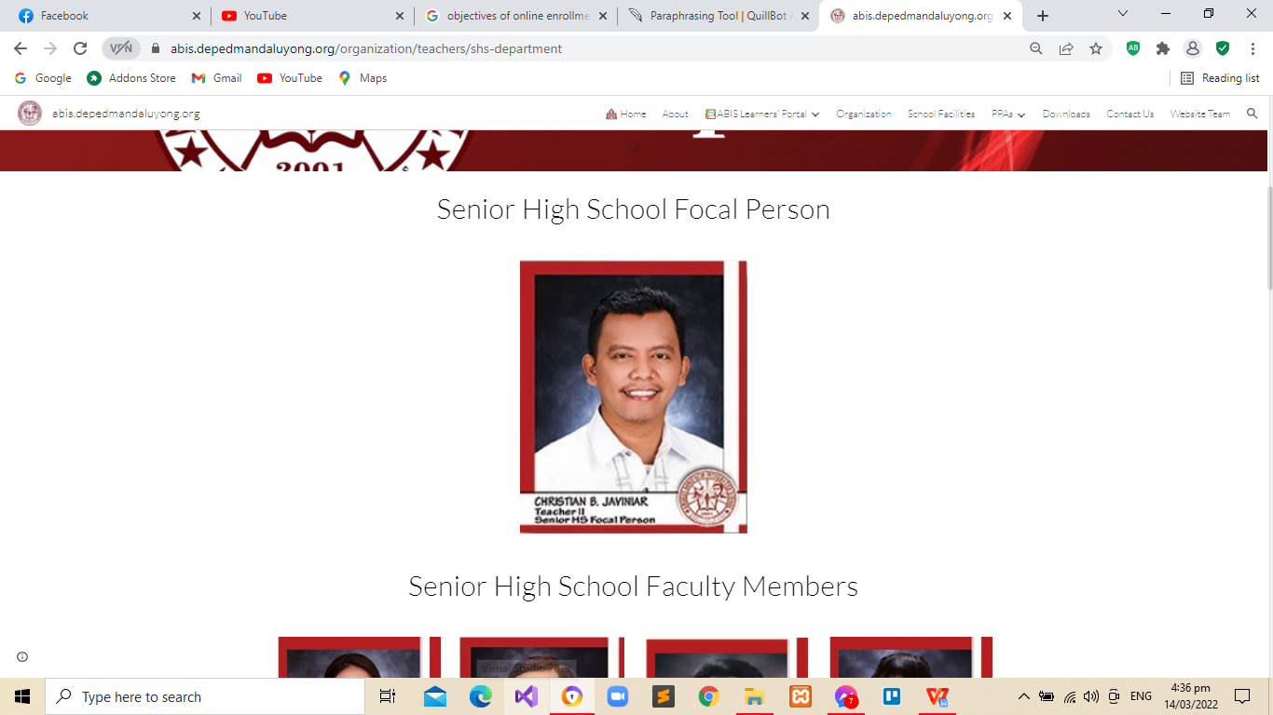

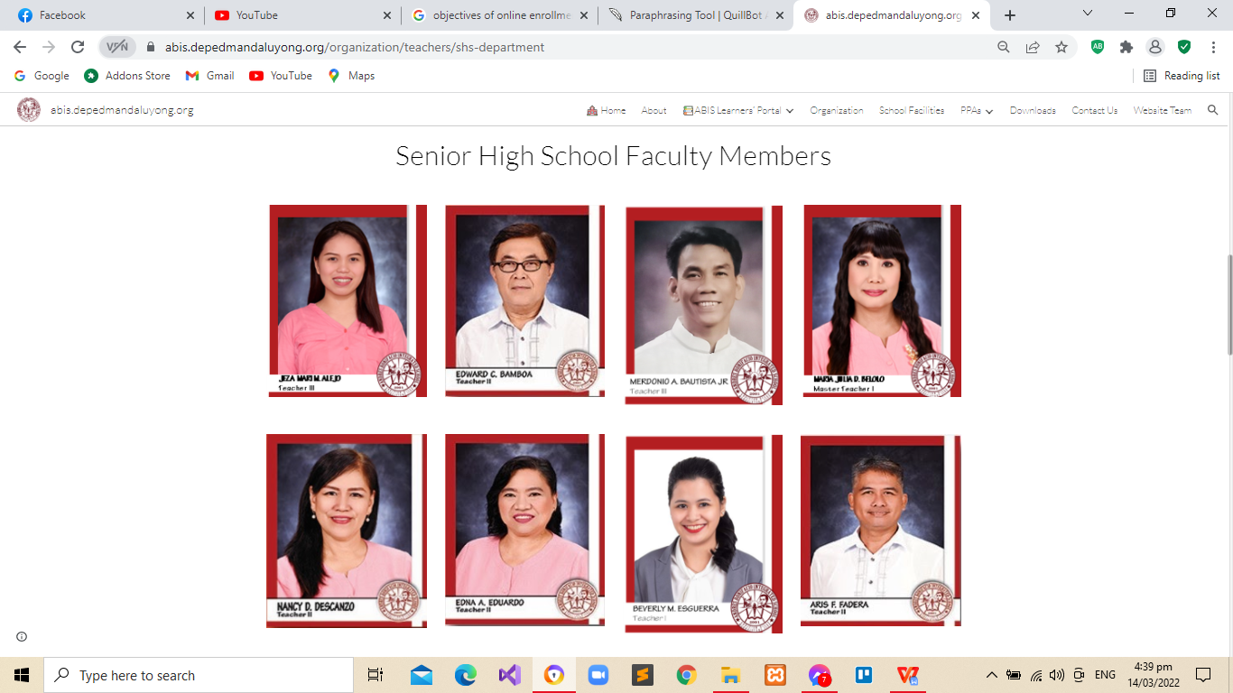

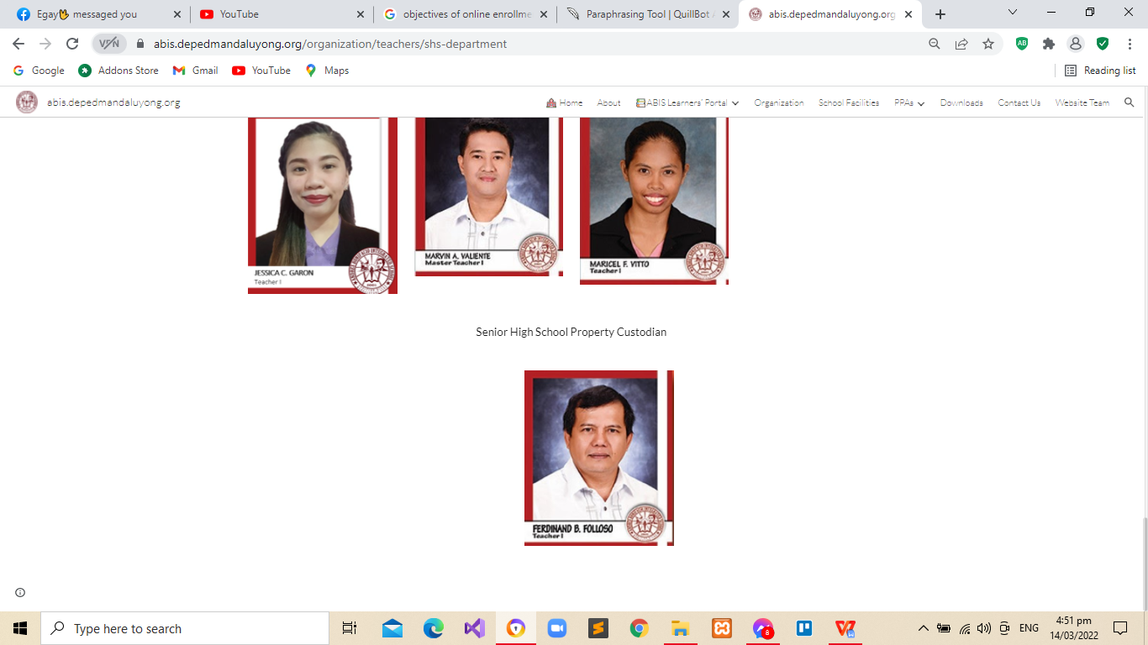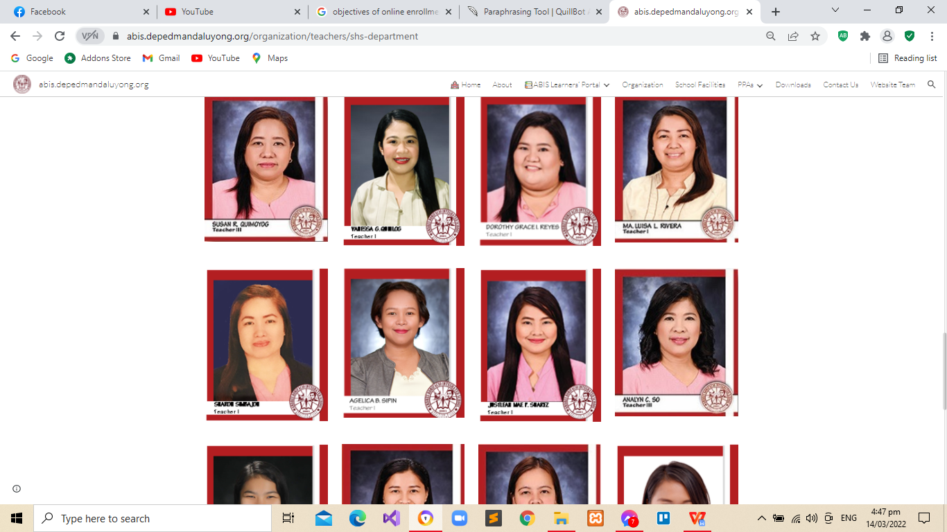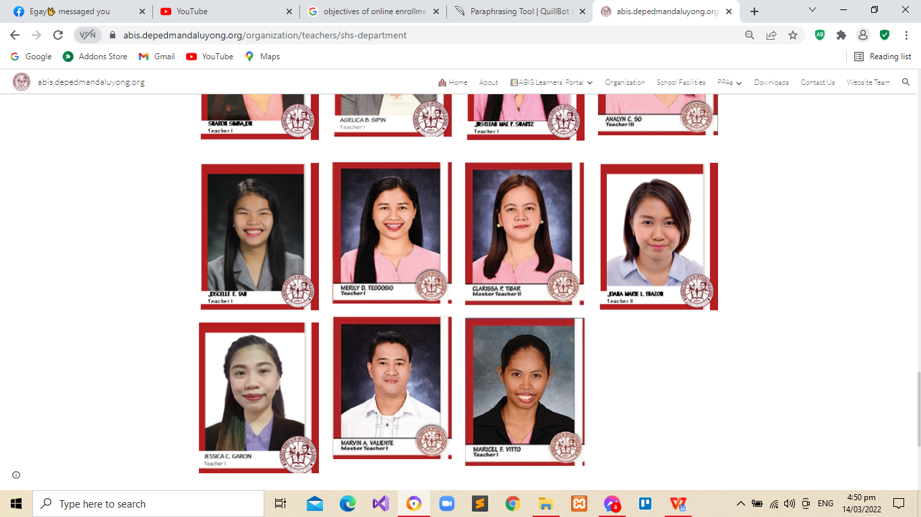

# STATEMENT OF THE PROBLEM

This proposal aims to present Online Grading System.

Especially, it seeks the following:

* Time consuming **–** All faculty members are using record book and Microsoft excel for computing and encoding grades for students. Also, they were using report card on releasing the grades of SHS of ABIS.
* Inconsistency of data or file

**-** Itcan cause of error, file handling and redundancy.

- Report cards of the students might have a risk of losing their cards.

* Difficult on getting report cards **-** Manual process of retrieving and releasing of records it causes slow progress.
* Human error **–** The record of the grades of every student in the record book may be at risk.
* Redundancy **–** It causes workload for the teacher and it affects the slow process when it comes to releasing grades for the students.

# OBJECTIVE OF THE STUDY

This study aims to improve the manual computing of grades and using card to the SHS of ABIS. The main goal is to design and develop a system that will serve as an online platform for teachers and students by creating automated grading system.

Specifically, the study aims to:

1. To design and construct a system for ABIS SHS students that will allow teachers to enter grades and release computed grades into the system.
2. To ease the overload and strain caused by the repeated work for teachers.
3. To provide computerized record of grades that will lessen to the teachers of ABIS SHS.
4. The system will allow students to view their grades in a more convenient and time saving way.
5. To maintain and keep a record of the grades of every student securely.

# REVIEW OF RELATED LITERATURE

## **Foreign Literature**

According to Debbie Hamilton, "Implementing an online gradebook program has been one of the best steps we have taken as a school to improve home-school communication and enhance student learning, we would never be able to do without it."

Eisenhower Middle School started using an online gradebook program school-wide during the 2003-2004 school year to improve communication with families. Parents were very appreciative of the efforts of teachers to learn the program and keep them informed about their children's academic progress. The program used by the school was not available after that first year, so a few staff members investigated online programs and discovered Grade Book Wizard. It was unanimously adopted by the instructional council for the next school year. At Eisenhower Middle School in Albuquerque, New Mexico, where Hamilton is principal, most parents check their children's grades regularly, and some even check them several times per day. Using the program Grade Book Wizard, teachers at the school can record and track student scores and grades. They can even choose to automatically email parents when an assignment is not turned in, giving parents the opportunity to communicate with their children about missed work immediately.

"This program is easy for teachers to use," said Gildea. "It provides constant access for teachers, the students, and their parents. It updates in real time, and parents can view all of their children's grades with one login password. Our experiences with security so far have been very positive."

<https://www.educationworld.com/a_admin/admin/admin467.shtml?fbclid=IwAR2W1k5HJdp7YnJ1aJVhpt2-ST1z1lPpnBMPyw0_26u3fV6wwVVQ9WYDg4I>

## **Local Literature**

Based on our interview to Mr. R. Arimbuyutan of college of Immaculate Conception they are using their Online Grading System for almost 6 years via SMS Technology features. And they demonstrate it how to use their Online Grading System. They also have the same logic as COGSYS the only difference is the customizable part that every school can use the COGSYS.

Based on the study of Andrienne Gail E. Ramos, etc... (2011) entitled Systematized Grading System of Canossa School High School Department. The school is having problems in transferring grades from one grade sheet to another. Re-checking and Re-encoding grades take some time. The proponents attempt to design and develop a grading system which it has the same process and flow as the old system. However, the proposed system has eliminated manual writing and the school staff can prevent time and energy consumption by using a system that guarantees accurate grade recording. It will also eliminate tons of papers used in computerized grading sheet, grading sheet per quarter, and summary sheet. The grade will directly encode in the system. Visual Basic is used as a tool for programming the functionalities of forms, buttons, menus, and encoding for grades. They also used Microsoft Access 2007 for the recording of data and grades of the students and Adobe Photoshop CS4 for editing images and icons for the interface of the system.

On the thesis A Computer-Based Generic Registration System by Ivan A. Layos (2002), he stated that computers are known for their speed, accuracy and efficiency. The proponent conducted this study that arrived to create a standard computer-based registration system for elementary and high schools. The software is designed to run on Windows 95, 98, NT, ME and 2000, Visual Basic 6 by Microsoft was the programming used in implementing the software product.

https://graduateway.com/systems-analysis-and-online-grading/?fbclid=IwAR1CA5dEgqMFd2mwW_TWjzdNCd3q8BDcrkcs2a5drEXEKUl2bDmwYZOcPkU

# OLD SYSTEM

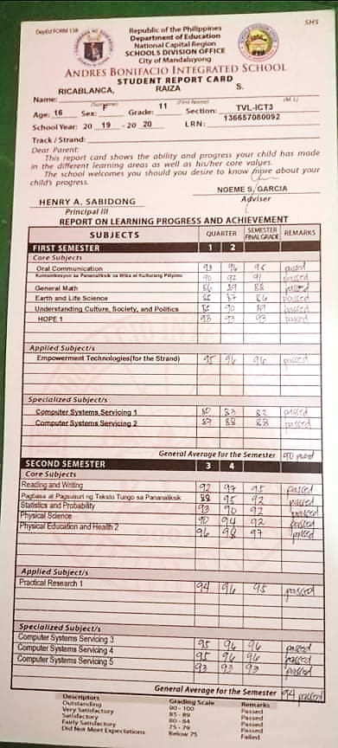

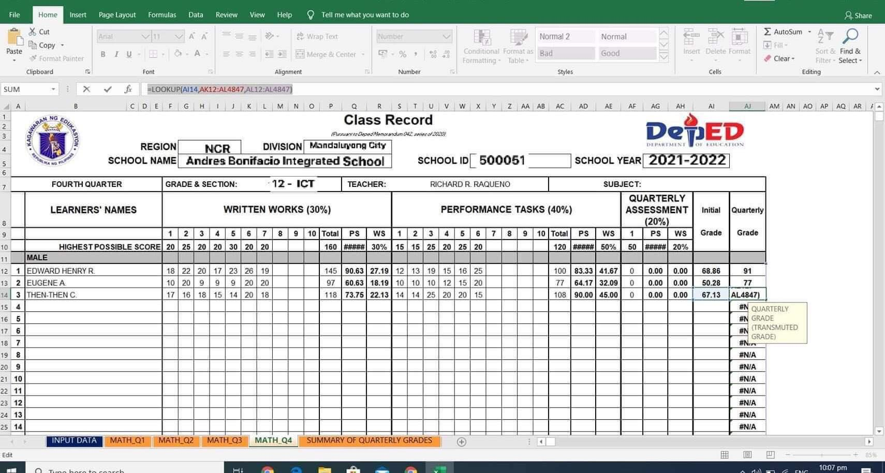

# OLD SYSTEM FLOWCHART

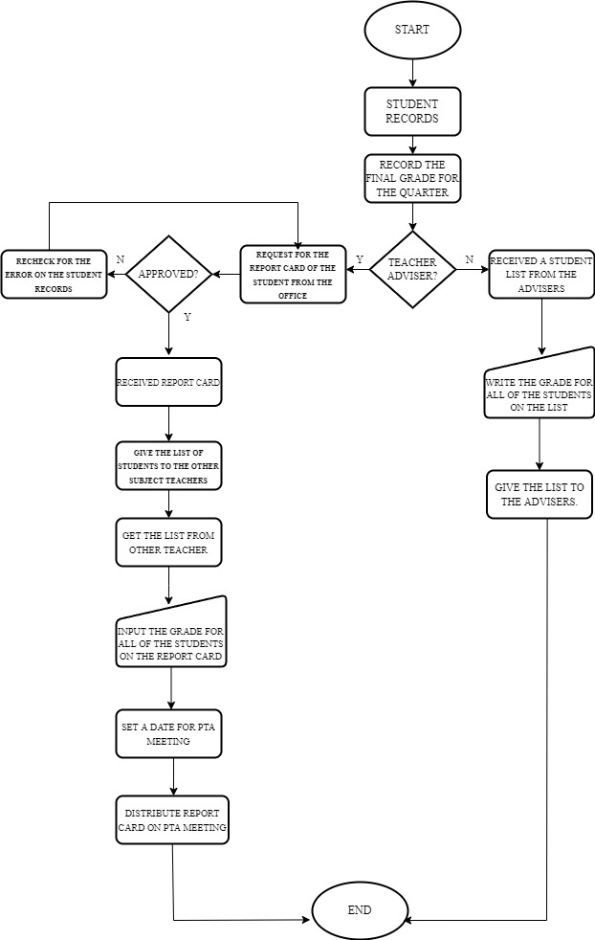

# NEW SYSTEM

**Teacher side**

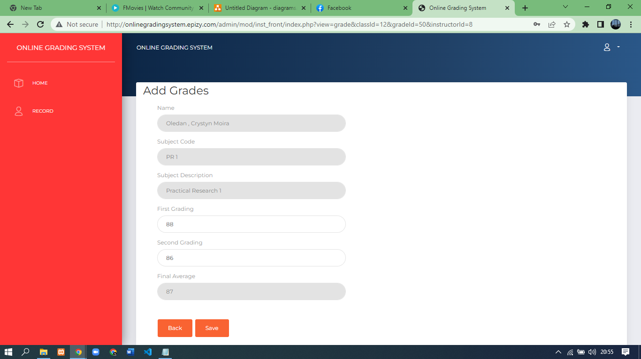

**Student side**

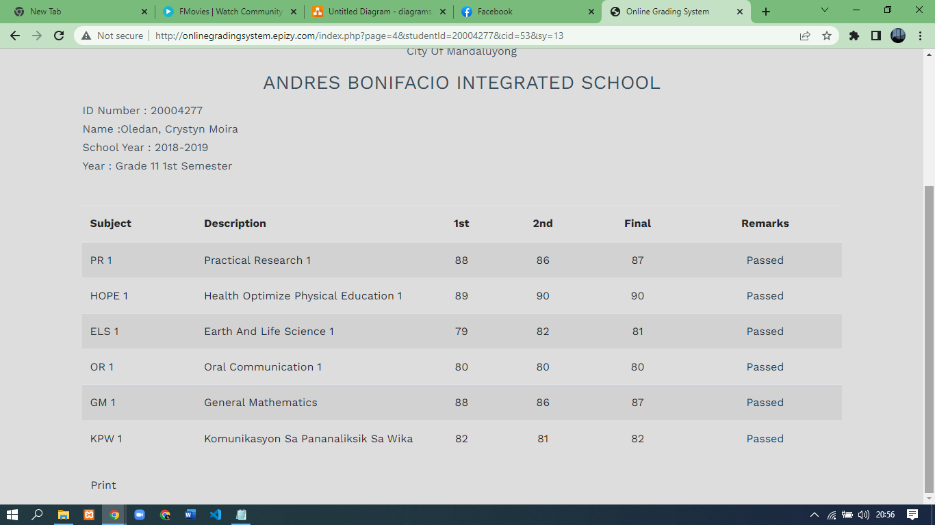

# DATA FLOW DIAGRAM

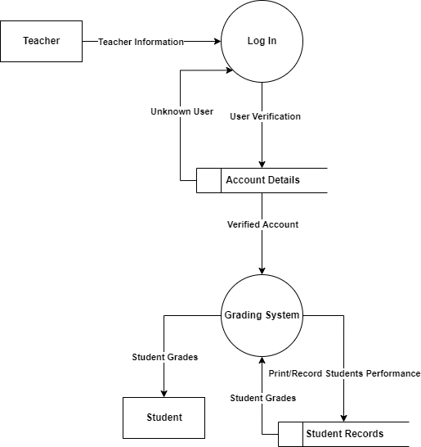

# SYSTEM FLOWCHART

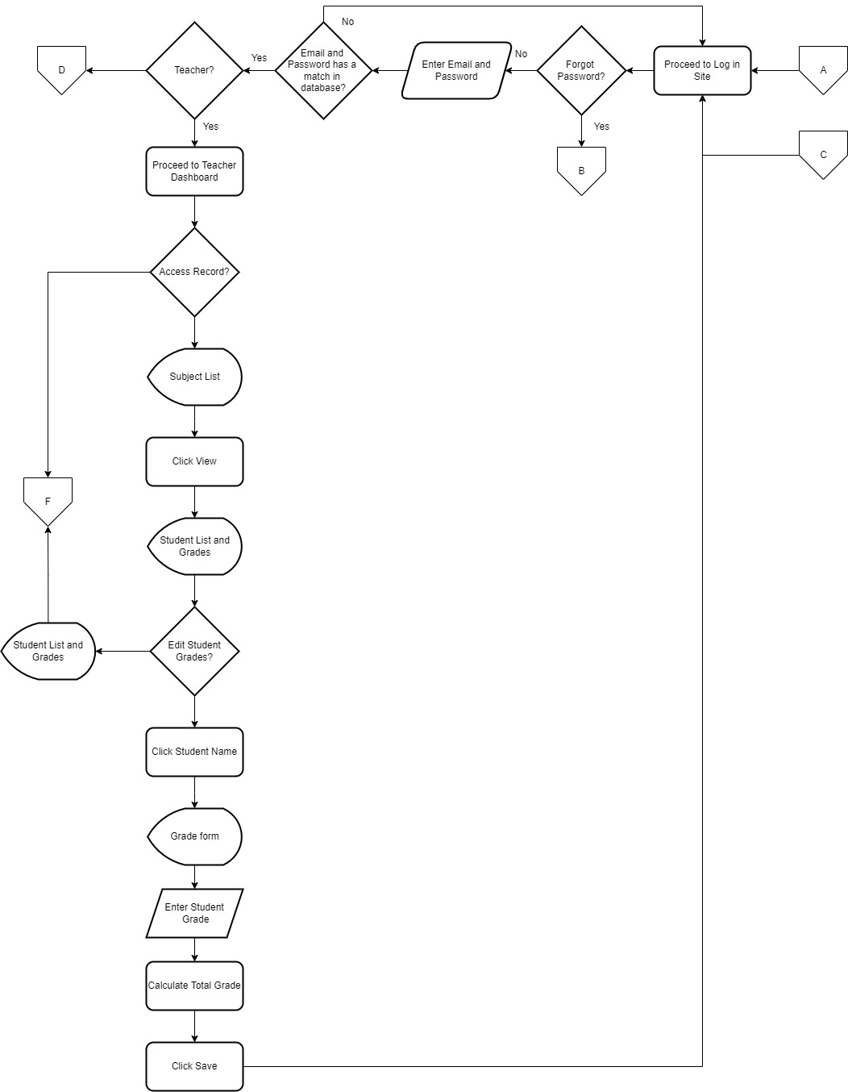

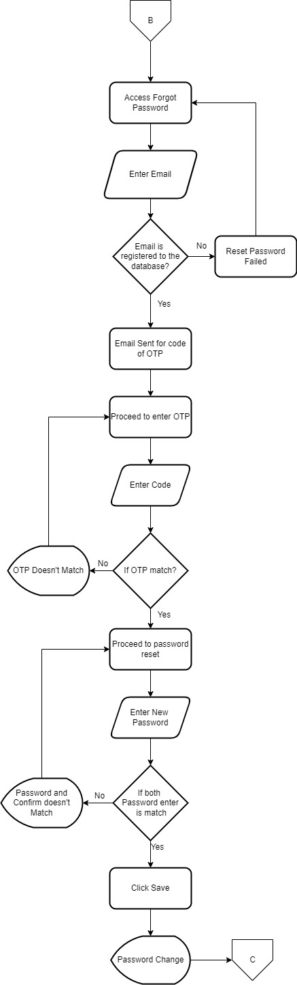

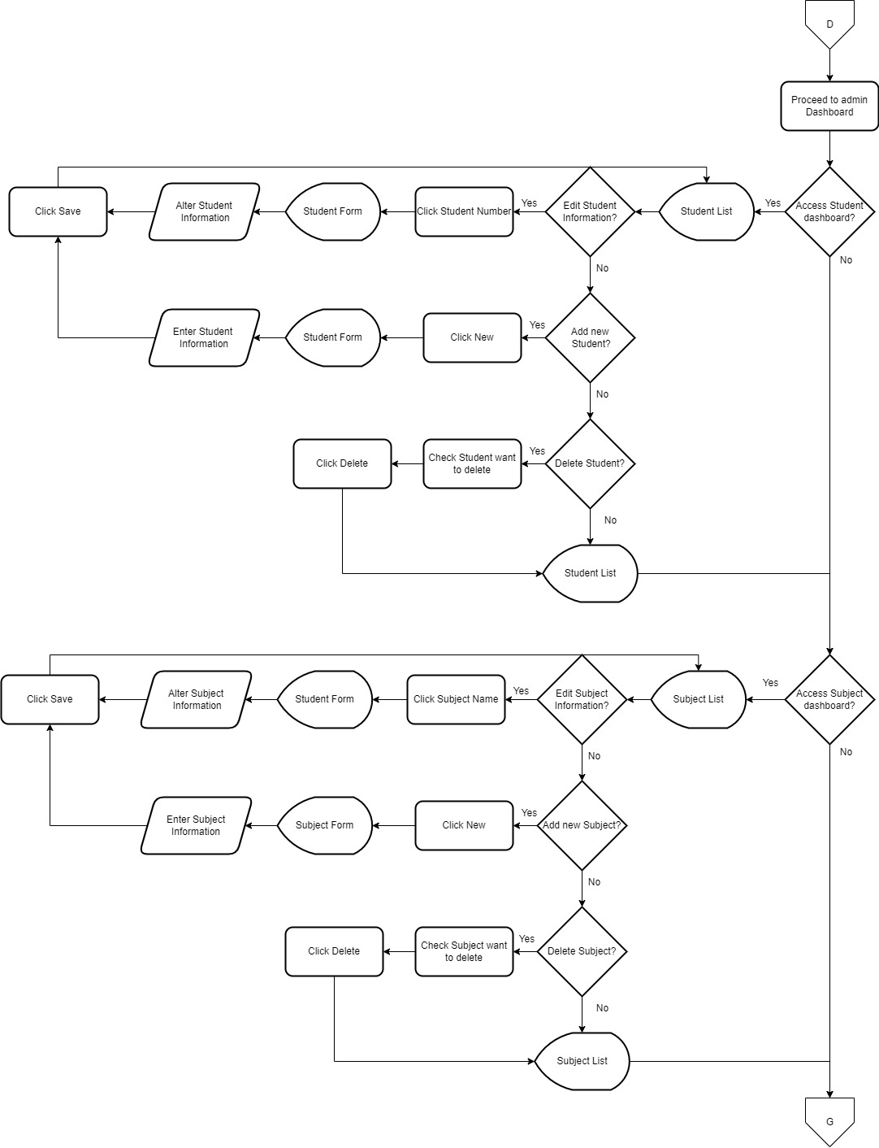

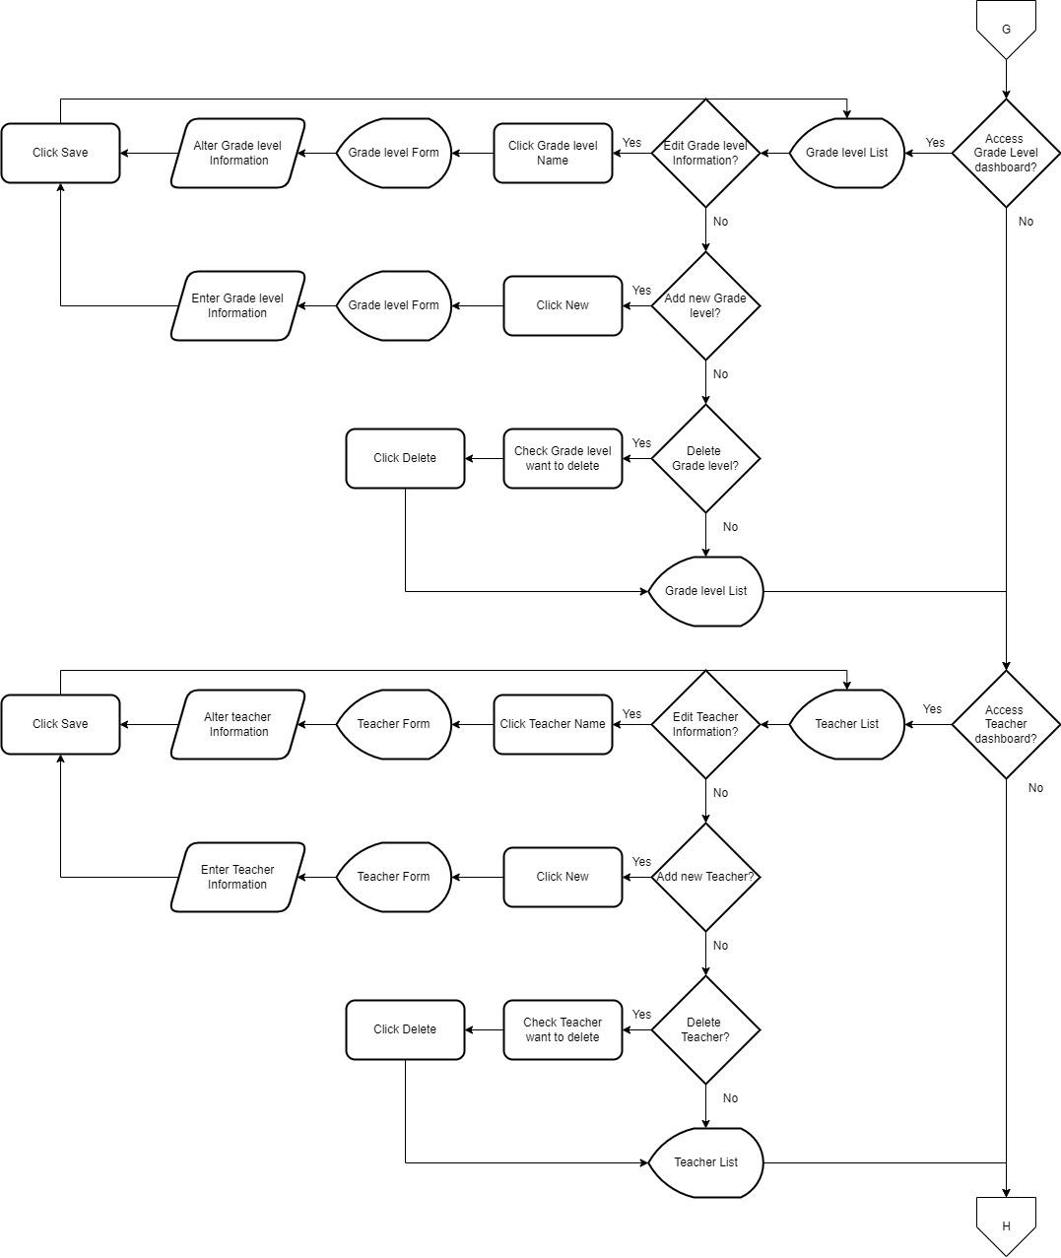

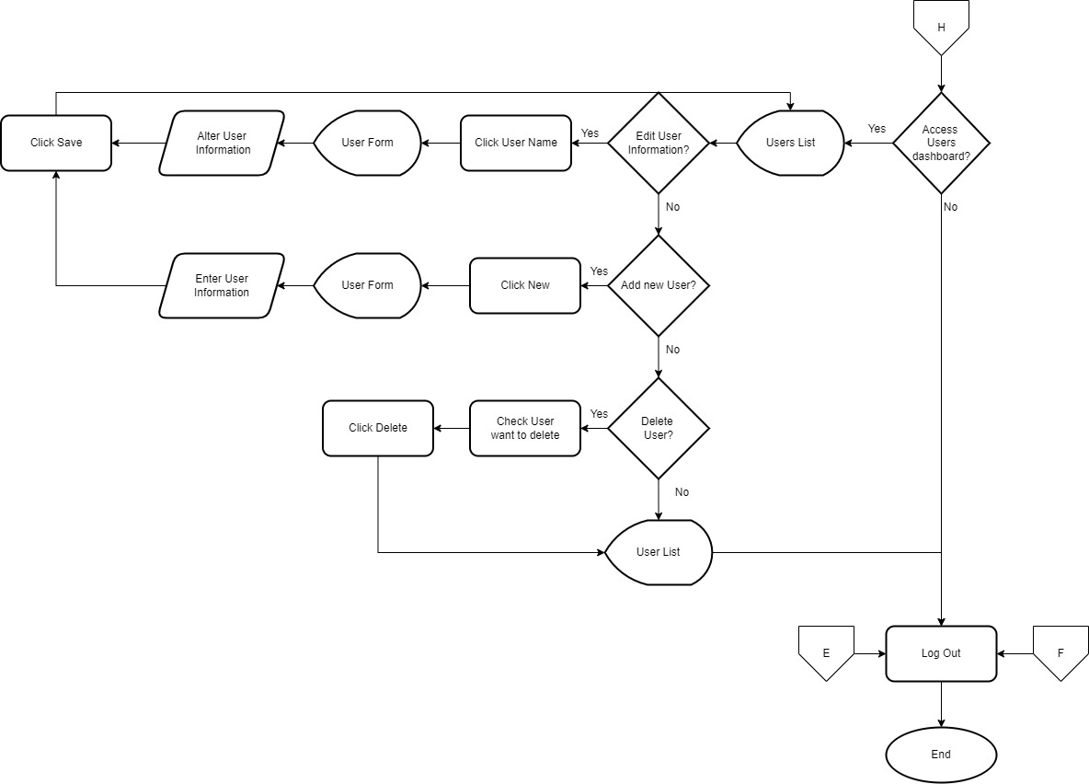

# PROGRAM FLOWCHART

# 

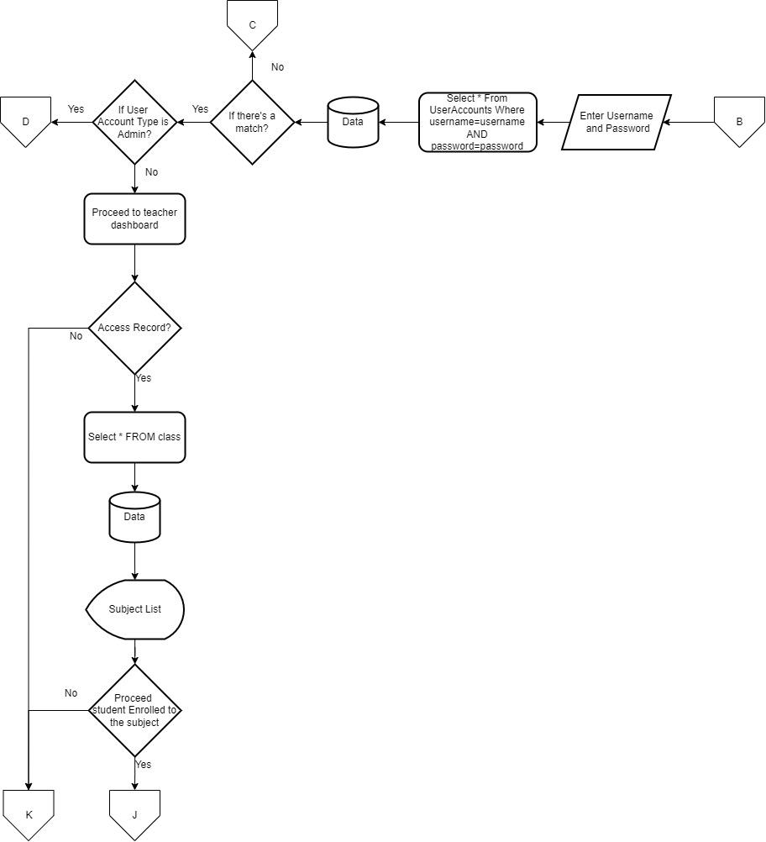

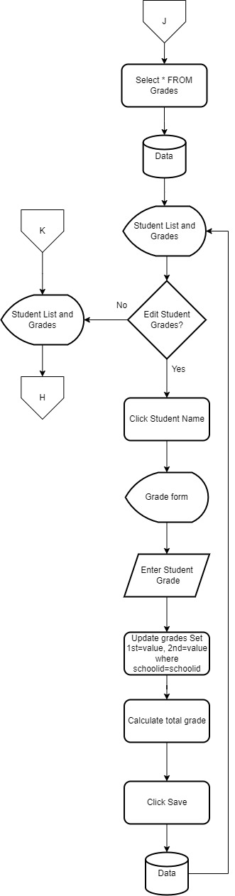

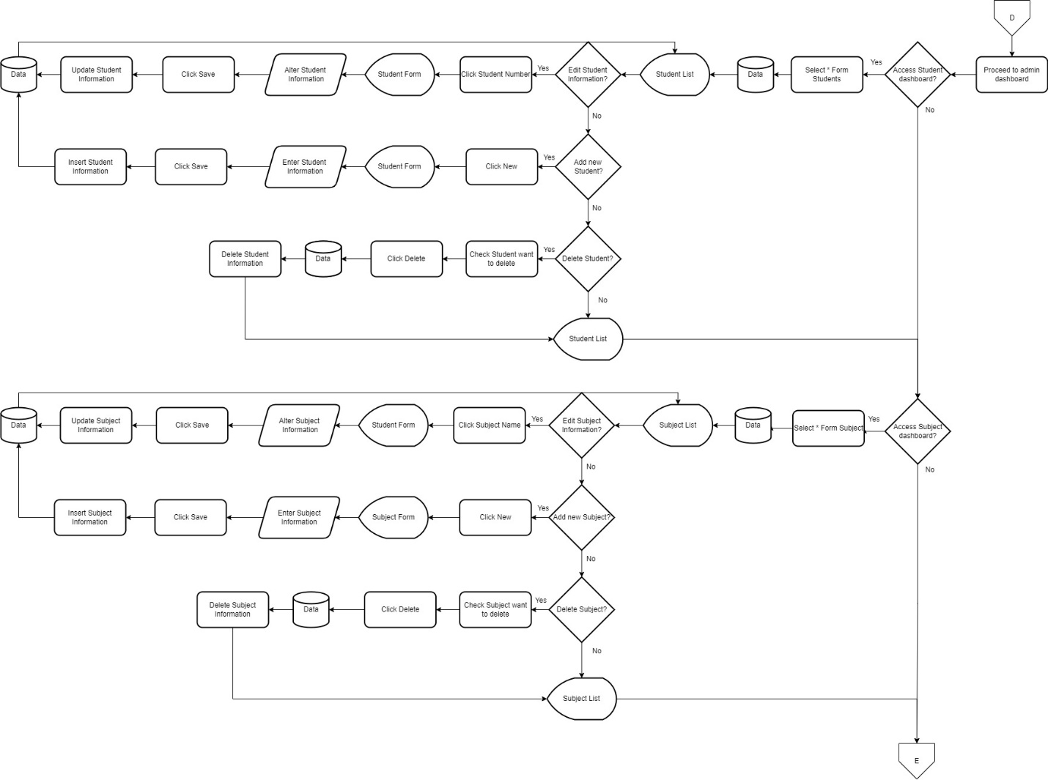

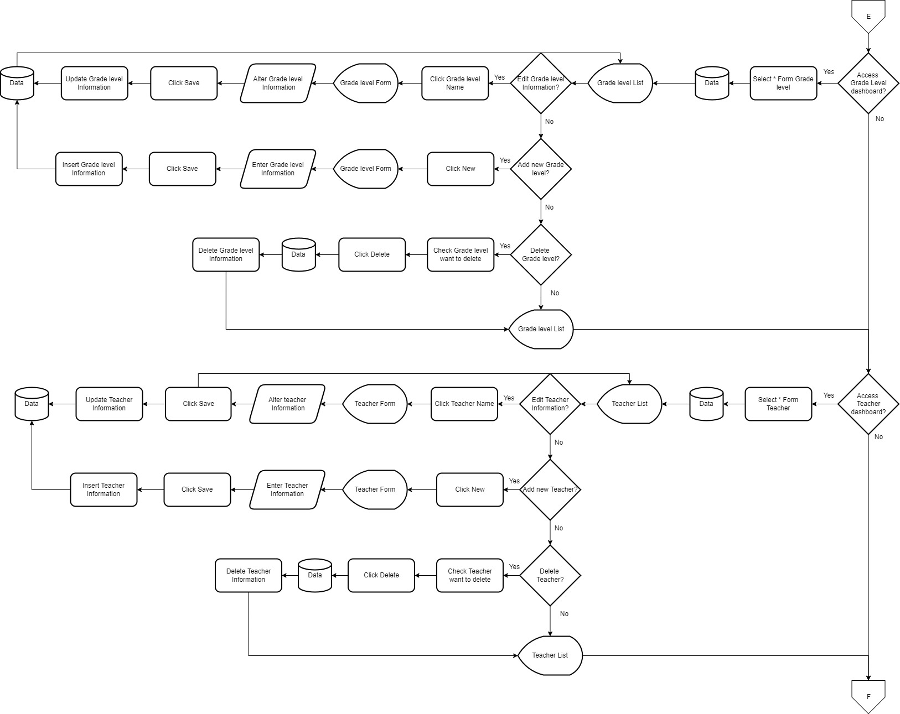

# DEFINITION OF TERMS

**Academic Setting -** is defined to be a classroom, office, laboratory, library, or field experience site where instruction, advising, or service occurs.

**Analytics and Statistics -** statistics focuses on analyzing, collecting, and interpreting data in a logical and usually numerical way, it makes sense that the techniques developed in Statistics are directly useful within Data Analytics. Analytics helps you form hypotheses, while statistics allow you to test them.

**Bugs -** is an error, flaw or fault in computer software that causes it to produce an incorrect or unexpected result, or to behave in unintended ways.

**End-users -** The person who actually uses a particular product.

**Gradebook -** is a new core tool for instructors to calculate and store grade information and distribute it to students online.

**Microsoft Excel -** is a software program produced by Microsoft that allows users to organize, format and calculate data with formulas using a spreadsheet system.

**Microsoft SQL Server Management Studio 2014 -** is a powerful and reliable free data management system that delivers a rich and reliable data store for lightweight Web Sites and desktop applications.

**Microsoft Visual Studio 2013 C#** - are programming languages designed for creating a variety of applications that run on .NET.

**MySQL -** is a relational database management system (RDBMS) developed by Oracle that is based on structured query language (SQL). A database is a structured collection of data.

**Questionnaire -** is a research instrument consisting of a series of questions for the purpose of gathering information from respondents through survey or statistical study.

# HARDWARE AND SOFTWARE REQUIREMENTS

**Hardware:**

* **OS –** Windows 8 or higher with latest updates installed
* **Processor –** Any CPU (Intel i3/i5/i7)
* **Memory –** 1GB RAM or higher
* **Storage –** 100MB available space
* **Internet connection –** network using 10Mbps or higher speed network adapter.

**Software:**

* Visual Studio Code
* XAMPP
* Any web browser
* Windows 7 and up

# CONCLUSION

Therefore, we conclude that this study was undertaken in order to implement an Online Grading System at this school, where students can view their grades by entering their ID number. It also saves paper because students don't have to go to school or wait in line to collect their marks. This approach also aids their efficiency because students may readily view their grades even when they are not in school. The goal of the online grading system is to convert the current grading system to the web. The major goal is to use the internet to view the student’s grades. It is meant for instructors to enter the first, second, third, and fourth grading grades on the web and have an automatic calculation.

# SUMMARY

The online grading system is a system that uses the Internet and allows teachers to manage class grades and submit grades. Professors/teachers can access student lists for each class they teach and perform standard school management, such as submitting final grades, incomplete information, and failure information. This information is stored in the Mysql database. This information becomes part of the student's academic records and transcripts. The system can keep track of students' numbers and grades. The system has a login feature that can help students access their own account through their ID number. We offer this system because it will work in an efficient way and as a way to help ABIS students have an online score survey. As students of information systems, we provide an online grading system that could help Andres Bonifacio Integrated school (ABIS) to have a grading system for students. The system is an easy way to search and get their points online. Advocates have also proposed the system to provide a starting point for senior high school students to consider coding their scores online. At the same time to reduce the workload of SHS teachers at ABIS.

# RECOMMENDATION

The researchers of the study highly recommend the developed of the Online Grading System and Grade Viewing in Andres Bonifacio Integrated School in SHS. The system ensuring that it can help students to view their grades without hassle and the teachers can manage and organized grades of each students. The researchers recommend for the future researchers, that they can use and maintain the data and study the system functionalities.

The system is highly recommended for it will make grade-related transaction easy, fast and hassle-free. The implementation of the developed Online Grading System with Grade Viewing is highly recommended for it ensures accuracy and fairness of grades.

# BIBLIOGRAPHY

San Jose, Camille., (2014) “Online Grading System.”

<https://prezi.com/sfbkfv02xkbo/online-grading-system/>

Smith, Gabrielle., (2016) “Grading System.”

<https://www.termpaperwarehouse.com/essay-on/Grading-System/30070>

Norem, Chriselle., (2014) “Computerized-Grading-System.” <https://www.slideshare.net/Chriselle24/computerized-grading-system-chapter-1-3>

<https://www.bartleby.com/essay/Computerized-Grading-System-FKSY5JKE3RYZA>

Hendra, S.Kom., M.T. & Yulyani Arifin, S.Kom., M.M., (2018) “Web-based Usability Measurement for Student Grading Information System” <https://www.sciencedirect.com/science/article/pii/S1877050918314601>

Marcial, Dr. Dave E., & Lalas Genesis (2016) “Developing a Grading and Monitoring System: Towards an Effective Academic Evaluation” http://www.uruae.org/siteadmin/upload/UH0516055.pdf

